Motores hacia la derecha
void setup() {
// put your setup code here, to run once:
pinMode(4,OUTPUT);
pinMode(5,OUTPUT);
pinMode(6,OUTPUT);
pinMode(7,OUTPUT);
pinMode(8,OUTPUT);
pinMode(9,OUTPUT);
pinMode(10,OUTPUT);
pinMode(11,OUTPUT);
}

void loop() {
// put your main code here, to run repeatedly:
digitalWrite(4,HIGH);
digitalWrite(8,HIGH);
digitalWrite(5,LOW);
digitalWrite(9,LOW);
digitalWrite(6,LOW);
digitalWrite(10,LOW);
digitalWrite(7,LOW);
digitalWrite(11,LOW);
delay(150);
digitalWrite(4,LOW);
digitalWrite(8,LOW);
digitalWrite(5,HIGH);
digitalWrite(9,HIGH);
digitalWrite(6,LOW);
digitalWrite(10,LOW);
digitalWrite(7,LOW);
digitalWrite(11,LOW);
delay(150);
digitalWrite(4,LOW);
digitalWrite(8,LOW);
digitalWrite(5,LOW);
digitalWrite(9,LOW);
digitalWrite(6,HIGH);
digitalWrite(10,HIGH);
digitalWrite(7,LOW);
digitalWrite(11,LOW);
delay(150);
digitalWrite(4,LOW);
digitalWrite(8,LOW);
digitalWrite(5,LOW);
digitalWrite(9,LOW);
digitalWrite(6,LOW);
digitalWrite(10,LOW);
digitalWrite(7,HIGH);
digitalWrite(11,HIGH);
delay(150);
}

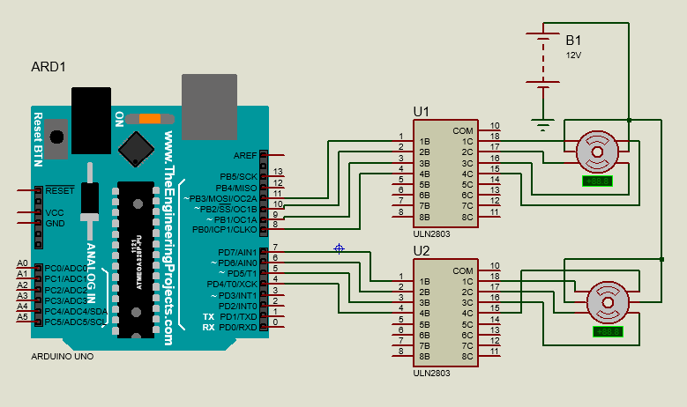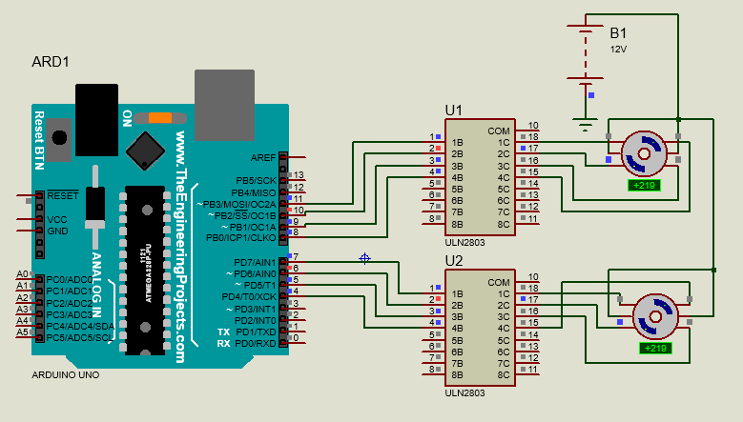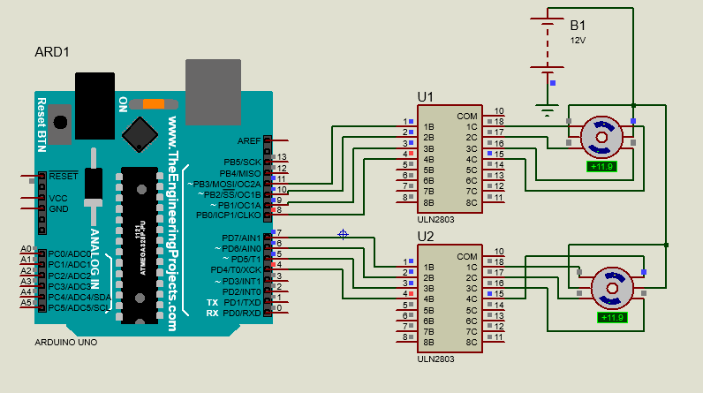
Hacia la izquierda
void setup() {
// put your setup code here, to run once:
pinMode(4,OUTPUT);
pinMode(5,OUTPUT);
pinMode(6,OUTPUT);
pinMode(7,OUTPUT);
pinMode(8,OUTPUT);
pinMode(9,OUTPUT);
pinMode(10,OUTPUT);
pinMode(11,OUTPUT);
}

void loop() {
// put your main code here, to run repeatedly:
digitalWrite(4,LOW);
digitalWrite(8,LOW);
digitalWrite(5,LOW);
digitalWrite(9,LOW);
digitalWrite(6,LOW);
digitalWrite(10,LOW);
digitalWrite(7,HIGH);
digitalWrite(11,HIGH);
delay(150);
digitalWrite(4,LOW);
digitalWrite(8,LOW);
digitalWrite(5,LOW);
digitalWrite(9,LOW);
digitalWrite(6,HIGH);
digitalWrite(10,HIGH);
digitalWrite(7,LOW);
digitalWrite(11,LOW);
delay(150);
digitalWrite(4,LOW);
digitalWrite(8,LOW);
digitalWrite(5,HIGH);
digitalWrite(9,HIGH);
digitalWrite(6,LOW);
digitalWrite(10,LOW);
digitalWrite(7,LOW);
digitalWrite(11,LOW);
delay(150);
digitalWrite(4,HIGH);
digitalWrite(8,HIGH);
digitalWrite(5,LOW);
digitalWrite(9,LOW);
digitalWrite(6,LOW);
digitalWrite(10,LOW);
digitalWrite(7,LOW);
digitalWrite(11,LOW);
delay(150);
}

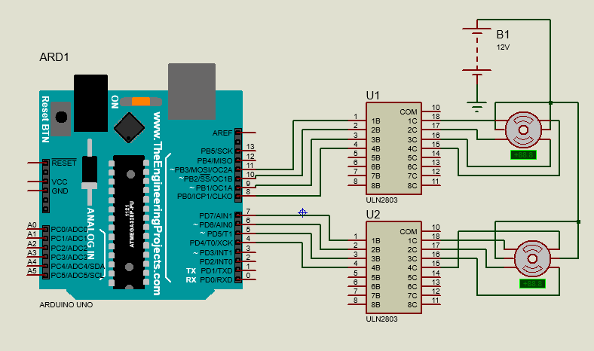
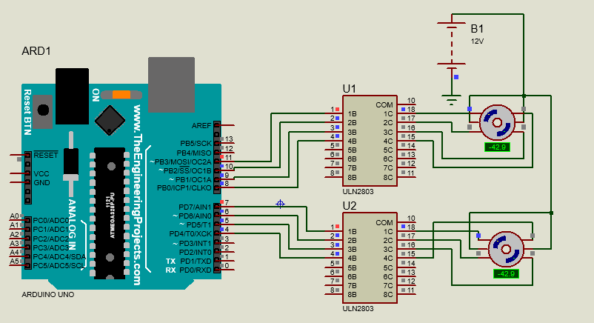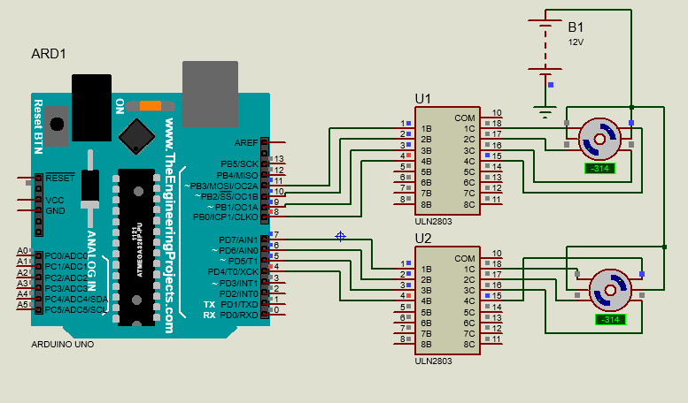
Uno hacia la derecha y uno hacia la izquierda
void setup() {
// put your setup code here, to run once:
pinMode(4,OUTPUT);
pinMode(5,OUTPUT);
pinMode(6,OUTPUT);
pinMode(7,OUTPUT);
pinMode(8,OUTPUT);
pinMode(9,OUTPUT);
pinMode(10,OUTPUT);
pinMode(11,OUTPUT);
}

void loop() {
// put your main code here, to run repeatedly:
digitalWrite(4,HIGH);
digitalWrite(8,LOW);
digitalWrite(5,LOW);
digitalWrite(9,LOW);
digitalWrite(6,LOW);
digitalWrite(10,LOW);
digitalWrite(7,LOW);
digitalWrite(11,HIGH);
delay(150);
digitalWrite(4,LOW);
digitalWrite(8,LOW);
digitalWrite(5,HIGH);
digitalWrite(9,LOW);
digitalWrite(6,LOW);
digitalWrite(10,HIGH);
digitalWrite(7,LOW);
digitalWrite(11,LOW);
delay(150);
digitalWrite(4,LOW);
digitalWrite(8,LOW);
digitalWrite(5,LOW);
digitalWrite(9,HIGH);
digitalWrite(6,HIGH);
digitalWrite(10,LOW);
digitalWrite(7,LOW);
digitalWrite(11,LOW);
delay(150);
digitalWrite(4,LOW);
digitalWrite(8,HIGH);
digitalWrite(5,LOW);
digitalWrite(9,LOW);
digitalWrite(6,LOW);
digitalWrite(10,LOW);
digitalWrite(7,HIGH);
digitalWrite(11,LOW);
delay(150);
}



